W-12
YEAR 10 SCIENCE (GENERAL)
PHYSICAL SCIENCE
TEST
Name: Mark: 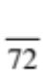

They apply relationships between force, mass and acceleration to predict changes in the motion of objects.

Part 1: Multiple Choice
MULTIPLE CHOICE ANSWERS
1
2
3
4
5
6
7
8
9
10
11
12
13
14
15
16
17
18
Write your choice for each question in the table below.

1. The change in position of an object in a particular direction is known as:

(a) displacement.
(b) distance.
(c) average speed.
(d) average velocity.

2. How long would a car travelling at a speed of 20 ms⁻¹ take to cover a
distance of 360 m?

(a) 13 s
(b) 26 s
(c) 18 s
(d) 34 s

3. Which line on the following graph represents a deceleration?

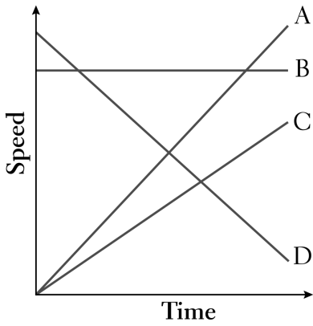
(a) A
(b) B
(c) C
(d) D

4. Which line on the following graph represents a constant speed?

(a) A
(b) B
(c) C
(d) D

5. The rate of change of speed of an object is known as:

(a) average speed.
(b) average velocity.
(c) change in velocity.
(d) acceleration.

6. An object starts from rest and accelerates at 5.0 ms⁻². After 4.0 seconds, its speed will be:

(a) 0
(b) 10 ms⁻¹.
(c) 20 ms⁻¹.
(d) 30 ms⁻¹.

7. The tendency of an object to resist changes in its motion is called:

(a) inertia.
(b) weight.
(c) friction.
(d) work.

8. Newton’s law, known as the law of inertia, is:

(a) his first law.
(b) his second law.
(c) his third law.
(d) none of the above.

9. Belinda walks a total distance of 1200 metres to school each morning. If this trip takes her
800 seconds, her average speed would be:

(a) 1.5 ms⁻¹.
(b) 0.67 ms⁻¹.
(c) 0 ms⁻¹.
(d) 960,000 ms⁻¹.

10. An object is acted upon by a force of 50 N pushing it forwards and a total frictional force of 40 N
acting in the opposite direction. The nett force will be:

(a) 10 N backwards.
(b) 10 N forwards.
(c) 90 N backwards.
(d) 90 N forwards.

11. The size of the acceleration acting on an object of mass 10 kg that has a net force of 3.0 N acting on it
will be:

(a) 13 ms⁻².
(b) 3.33 ms⁻².
(c) 0.3 ms⁻².
(d) 30 ms⁻².

12. In which of the following graphs would the object cover the greatest distance in the time shown?

(a) A
(b) B
(c) C
(d) D

13. The force of gravity acting on an object is called:

(a) inertia.
(b) weight.
(c) friction.
(d) work.

14 The weight force acting on a 20 kg mass on the Earth would be:

(a) 19.8 N
(b) 198 N
(c) 1.98 N
(d) 0 N.

15. In the diagram below the arrows show the size and direction of two force arrows acting on the bike.

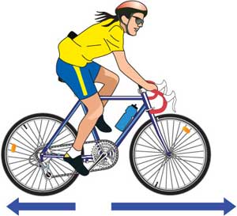

Which of the following describes the effect of the pair of forces on the bike?

(a) The bike will accelerate forward.
(b) The bike will change its direction of motion.
(c) The bike will remain stationary.
(d) The bike will decelerate.

16. What is the acceleration of a car if it increases its velocity from 5.0 ms⁻¹ to 15.0 ms⁻¹ in
4.0 seconds?

(a) 2.5 ms⁻¹
(b) 15 ms⁻²
(c) 2.5 ms⁻²
(d) 5.2 ms⁻²

17. The sample of ticker tape below shows:

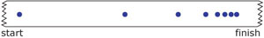

(a) a uniformly accelerating vehicle.
(b) a vehicle travelling at a constant velocity.
(c) a stationary vehicle.
(d) a uniformly decelerating vehicle.

18. A vector has:

(a) direction only.
(b) magnitude only.
(c) both direction and magnitude.
(d) neither magnitude nor direction.

Part 2: Short Answer

Decide whether each of the following statements is true (T) or false (F).

(a) Average speed is calculated by distance covered multiplied by the
time taken.

(b) 40.0 km/h = 144 m/s

(c) When a car accelerates quickly, you move forward in your seat.

(d) A negative acceleration occurs when a car goes backwards.

(e) A ticker timer putting 50 dots per second on the tape means that each
dot is 0.02 seconds apart.

(f) The graph below shows constant speed.
distance
time

(6)

2. Some students investigated the acceleration of a dynamics trolley down an incline plane using a ticker
timer to record the motion. The timer puts 50 dots per second (1 dot spacing = 0.02 s) onto the tape,
and the tape is shown below.

. . . . . . . . . . . . . . . . . .

Three groups of 5 dot-spacings are indicated on the diagram.

(a) Calculate the velocity for each section of the tape. Show your working clearly.

(6)

(b) Graph the velocities versus time on the grid below.

(4)

(c) Calculate the gradient of the line of best fit for the graph, which gives the acceleration of the
object.

(3)

3. Convert the following.

(a) 45 kmh⁻¹ = ms⁻¹ (b) 2.45 hours = s

(c) 34500 g = kg (d) 23.5 km = m (4)

4. The motion of a car is shown in the graph below.
Velocity (ms⁻¹)
0
5.0
10.0
15.0
20.0
10.0
20.0
30.0
40.0
50.0
Time (s)

(a) On the graph, label each part (there are 6 parts) with a description of the type of motion
occurring.

i.e. Acceleration, deceleration, constant velocity, etc.
(3)

(b) Assuming the car has moved in a straight line, calculate the displacement of the car after 40.0 s.

(3)

5. A dragster accelerates from rest at 14.5 ms⁻² for 6.90 s during a race. What is the velocity of the vehicle after this time? (Set your working out clearly.)

(3)
6. The Space Shuttle lands at 270 kmh⁻¹ (75.0 ms⁻¹) and immediately pops a drag chute to assist its
brakes to stop the vehicle. Assume that the braking forces are uniform for this motion.

(a) If it takes 14.5 s to stop, calculate the deceleration experienced by the crew.

(3)

(b) If the mass of the Shuttle is 34,500 kg, what is the average force exerted by the brakes and the
chute?

(3)

7. An object has a mass of 6.00 kg.

(a) What is its weight on Earth?

(2)
(b) Would the object weigh more or less on the Moon? Explain your answer.

(2)
(c) What is its mass on the Moon?

(1)

8. In moving around Victoria Square, a Year 7 student was observed to make the following
movements.

(i) Moved 10.0 m due south to talk with another student (time taken = 5.0 s).
(ii) Then moved 20.0 m due east to her locker to get some books (time taken = 15.0 s).

(a) Draw a vector diagram to show the motion. Draw in the resultant vector (use a different
colour). (Use a scale of 1.0 cm = 5.0 m).

(3)

(b) What is the total distance covered by the student?

(1)

(c) Determine by calculation the displacement of the student.

(3)

(d) Calculate the average speed of the student.

(2)

(e) Calculate the average velocity of the student.

(2)

